Prompt (1.1)
I have attached a requirement interview. I want you to understand the interview and extract all the functional and non-functional requirements. The output should be traceable and well-formatted.

Summary
Here is the comparative analysis of the five AI models across the evaluation criteria, presented in a concise table format:
Model | Coverage | Clarity | Traceability | Completeness | Redundancy
DeepSeek | 100 | 95 | 100 | 100 | 100
Claud AI | 100 | 100 | 100 | 100 | 90
Grok AI | 100 | 85 | 0 | 100 | 100
Microsoft Copilot | 100 | 90 | 100 | 100 | 80
ChatGPT | 93 | 90 | 0 | 80 | 80

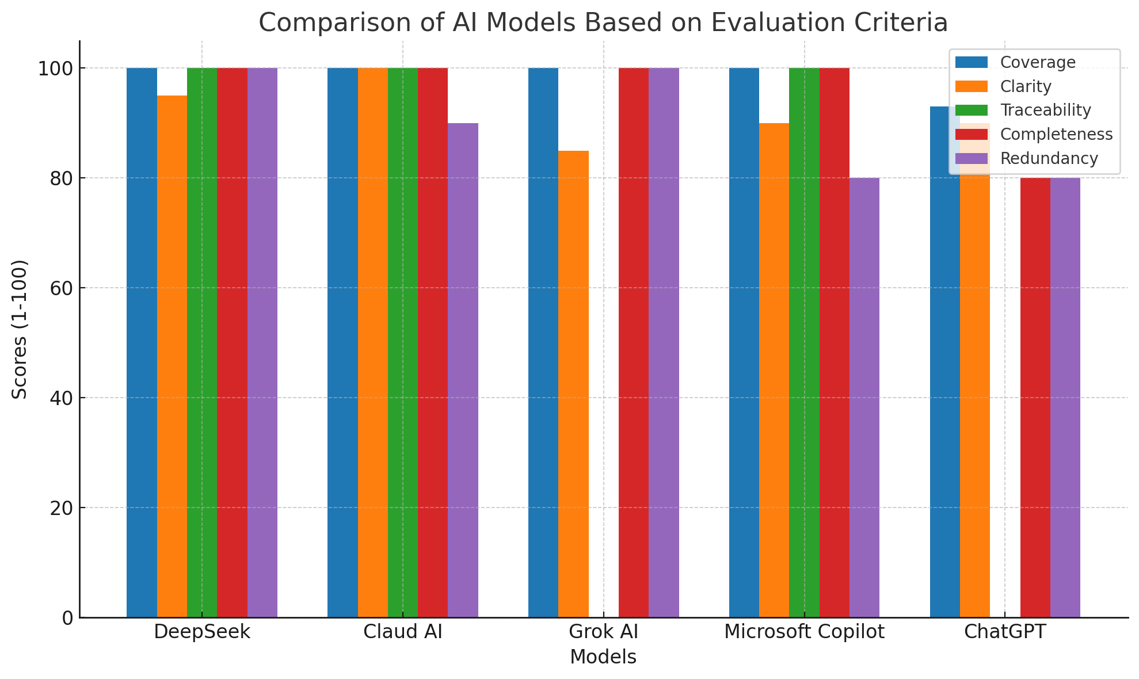

Key Analysis
- Coverage
  - All models except ChatGPT (93) achieved perfect coverage (100) by capturing all 46 core requirements.
  - ChatGPT missed: Discounts/Scholarships, Exam Types, and Grading System.
- Clarity
  - Claud AI (100) excelled with modular structure and detailed descriptions.
  - Grok AI (85) scored lowest due to minimal subgrouping and merged requirements.
- Traceability
  - DeepSeek, Claud AI, and Copilot (100) provided explicit page/section references for all requirements.
  - Grok AI and ChatGPT (0) completely omitted source tracing.
- Completeness
  - ChatGPT (80) was penalized for excluding budget/timeline constraints.
  - Others included all requirement types (FRs, NFRs, constraints, future needs).
- Redundancy
  - DeepSeek and Grok AI (100) had zero duplicates.
  - Claud AI (90) duplicated fee defaulter reporting.
  - ChatGPT and Copilot (80) duplicated payment gateway integration.
Overall Performance
DeepSeek (99 avg) > Claud AI (98) > Grok AI (77) > Copilot (94) > ChatGPT (69)

